*Student Wellness Center*

**Wellness Wheel App:**

*Development Team:*

*Simon McGann, Geovanni Roberts, Kelbin Rodriguez-Landavery, Paul Noujaim*

User Manual

Registering an user account:

When entering the app as a user, you will be presented four text fields and a radio button. Enter your email, choose a username and password, and select the living situation that most closely matches your own. Once these inputs are given, click the “Register” button. If the username has already been chosen by another user, you will be prompted to enter a new one. Additionally, if the two passwords do not match, you will be prompted to make them match. Below the “Register” button, is a link to the signin page, if a user reaches the “Register” page in error.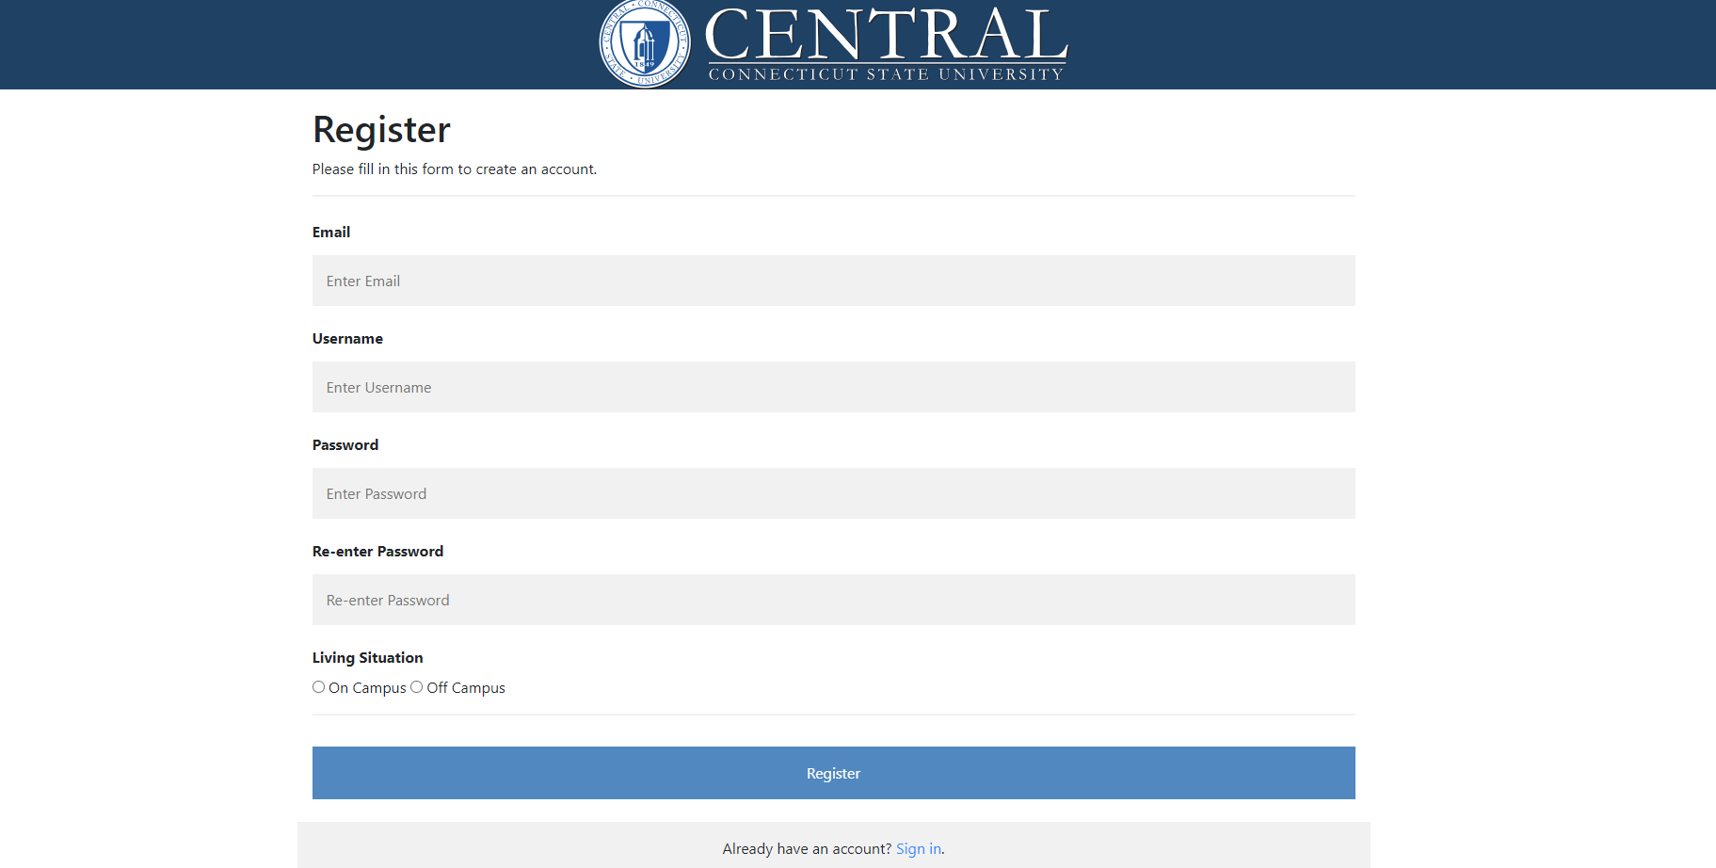

Registering an administrator account:

To register a new user as an administrator, the user must be logged in to an existing administrator account. From there, the user can navigate to the account settings and press the “Create admin account” button. Once clicked, a page identical to the previous registration form will appear.

Changing your password:

A user’s password can be changed by logging in and accessing the account settings page and clicking the “Change Password” text beneath the displayed email. The user will be redirected to a form prompting for their current password, their new password, and a confirmation field for the new password. Upon correctly entering this information and pressing “Change Password”, their password will be changed.

Using the Wellness Wheel:

When the user reaches the Wellness Wheel page, they will be presented with a large Wellness Wheel. Hovering over each slice will display tooltips in the box below the wheel, giving a brief description of that wellness type. 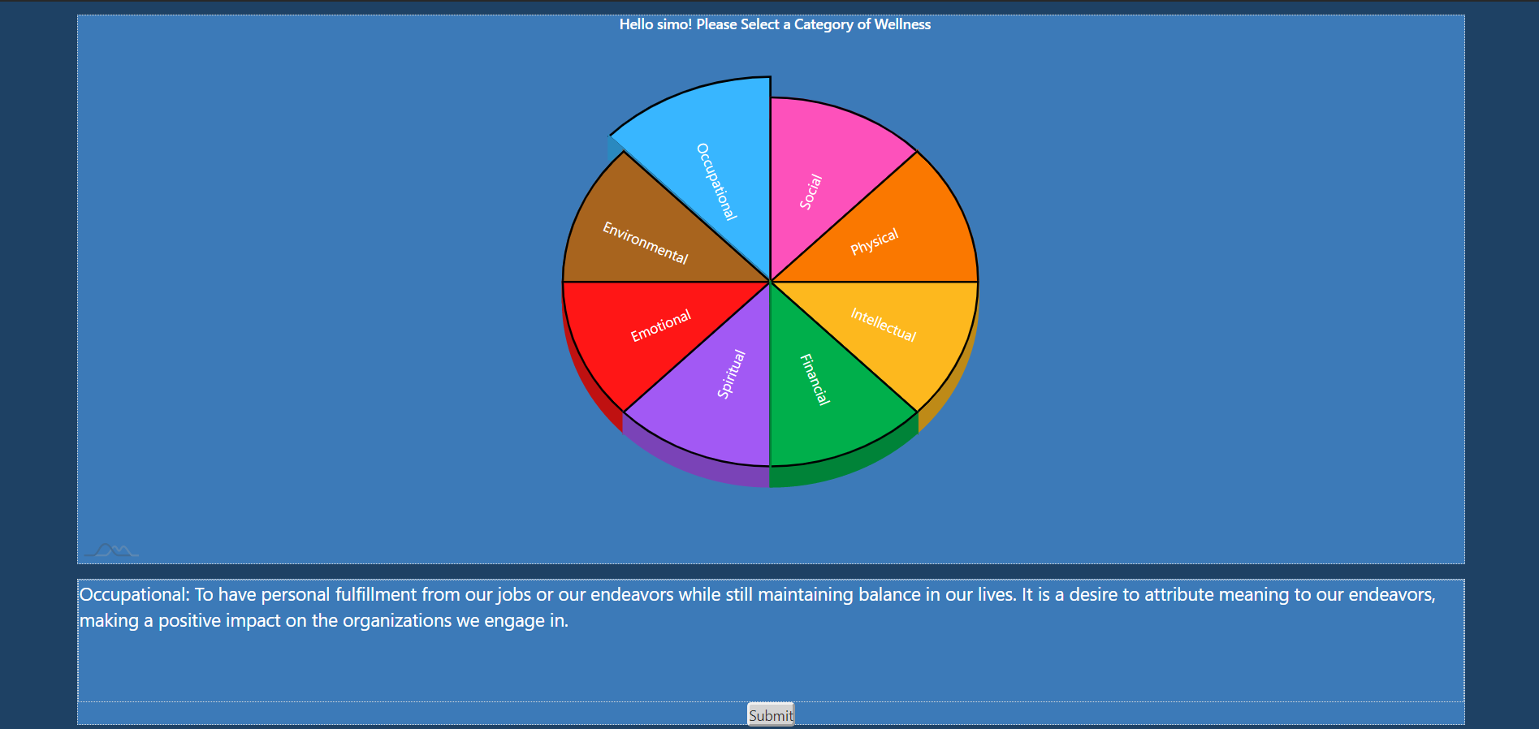

Clicking on a slice will hide the large wheel and show a smaller wheel and a slice. One slice in the small wheel will be pulled out from the rest of the pie. This indicates which wellness type you have selected and are giving a response for. The text above the slice indicates what your last response was for this particular wellness type. If this is the users first visit to the app, the text will indicate that no previous selection has been made. The three sections of the slice, on the right side of the screen, correspond to “Well”, “Neutral”, and “Not Well.” Hovering over each segment will display a tooltip in the box below, describing each response in the context of the selected wellness type. 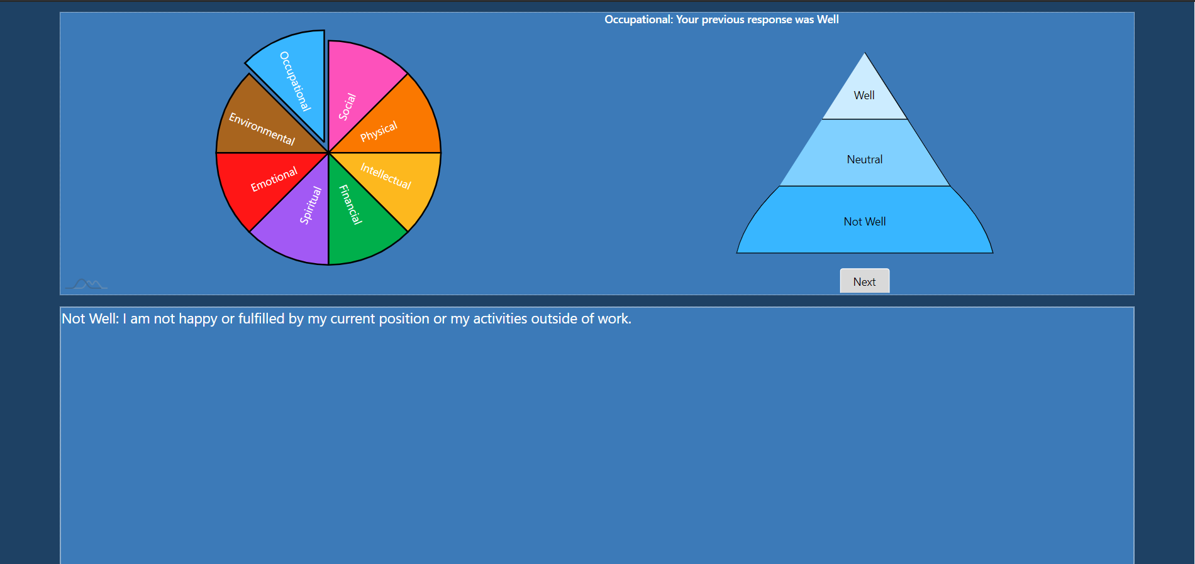

Clicking a segment and clicking the button marked “Next” will save your response and display the resources and resource links stored for that wellness type. 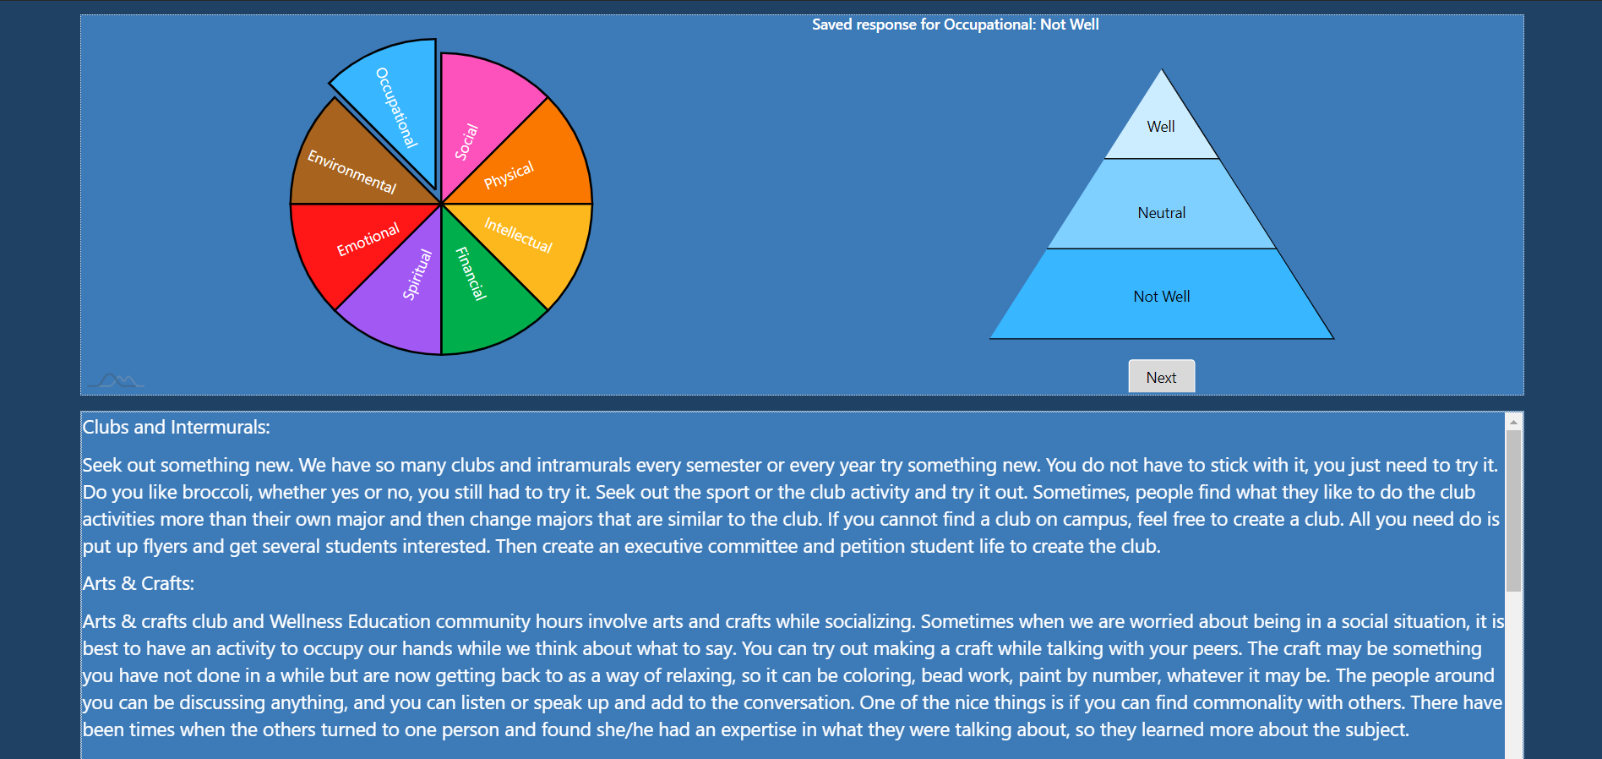

If the user does not give a response before clicking next, they will be prompted to return to the big wheel and try again. The user can either click the back button or click on the small wheel to return to the large wheel. The same procedure can be followed for each of the 8 types of wellness. Once the user has given a response to a particular type of wellness, that slice will remain pulled out from the large wheel.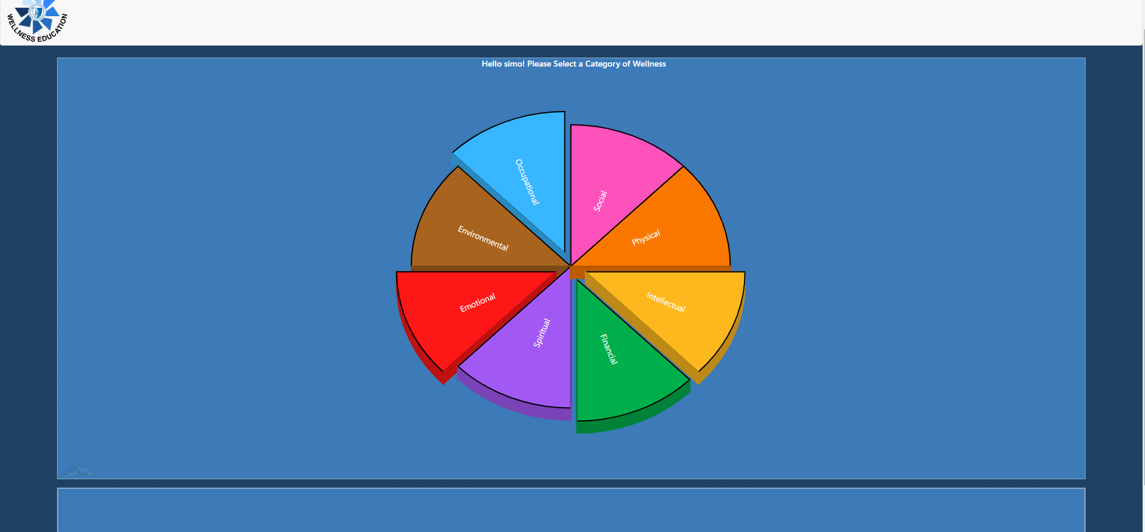

Once the user has given responses for the wellness types they want, they can click the submit button. The app will check if a response has been given for each wellness type. If they have not, the app will suggest they go back and give responses for any wellness types they may have missed. If the user chooses to do so, they can click the button marked “No, Let me go back” and they will be able to interact with the wheel again. 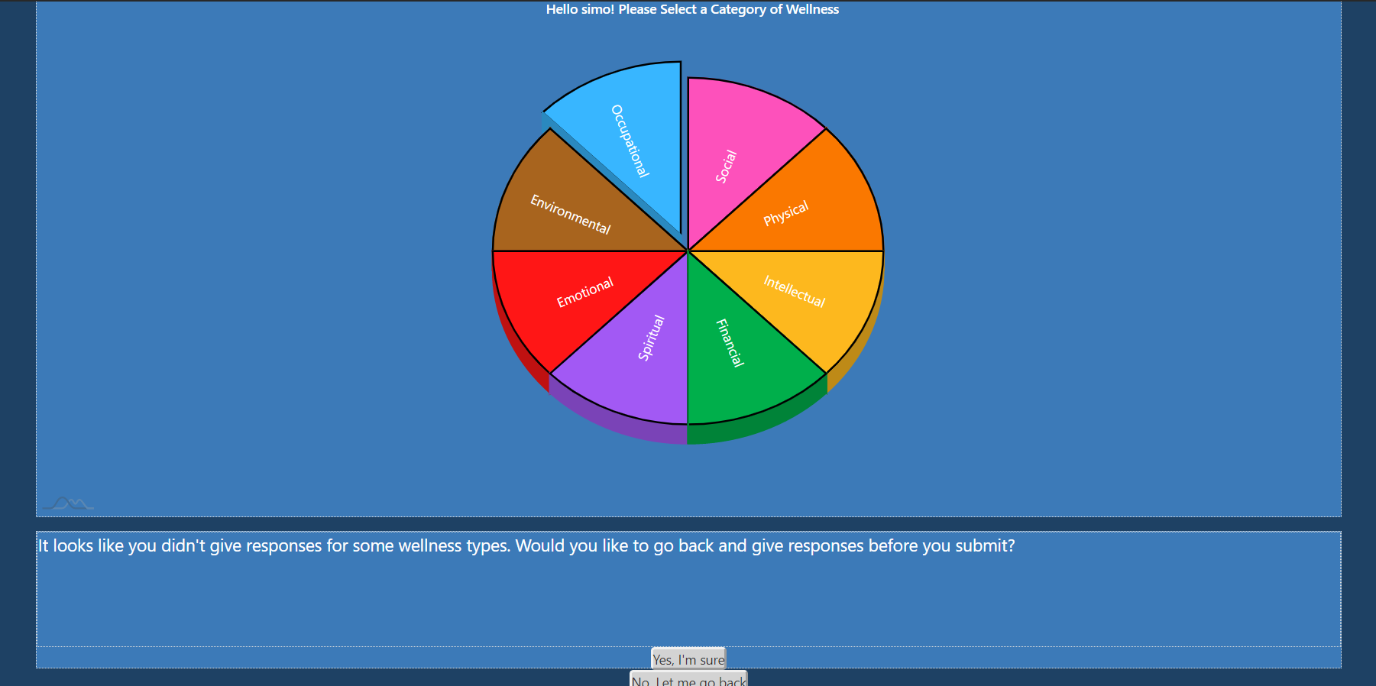

If the user does not wish to give any more responses, they can select the button marked “Yes, I’m sure.” This will submit the responses to the database. Users can use the nav bar at the top of the page to access and modify their account settings as well as an “About Us” page about the development team. Clicking on the CCSU Student Wellness Logo will bring the user to the Wellness Center’s website. Users can also click on the sign out button to sign out of the app. This will redirect the user to the sign-in page.

Generating Report as Administrator:

The report page contains 10 graphs that represent data from the database. The graphs are as follow:

Graph2 (Registered Users): Shows the total amount of users who are registered with the web-app including admin accounts.

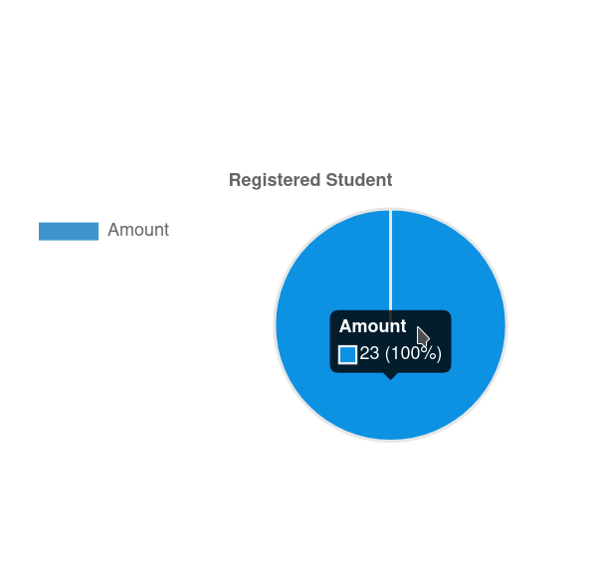

Graph2(Wellness Session Count): Shows the number of current wellness sessions. Although a user can have multiple (countless) wellness sessions, the count represents the most recent session of each user.

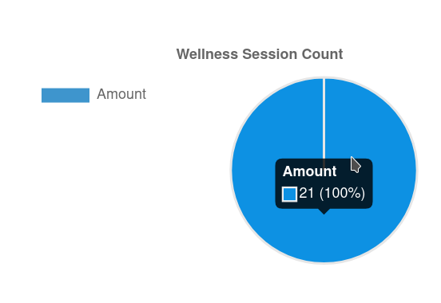

Graph3 (On/Off-campus): Shows the percentage as well as the total number of registered users who live on campus.

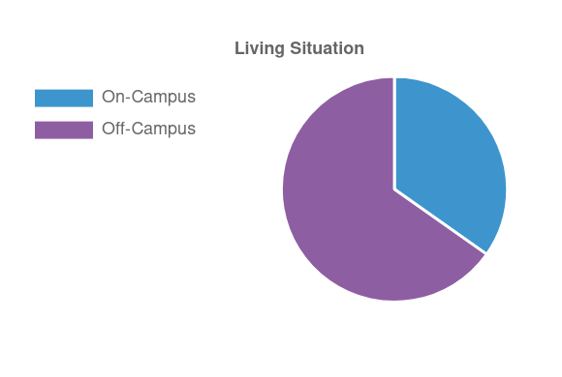

Graph 4-11 (Factors of Wellness): These graphs represent the eight different factors of wellness with each graph having the percentage and number representing well, neutral, and not-well for each factor of wellness.

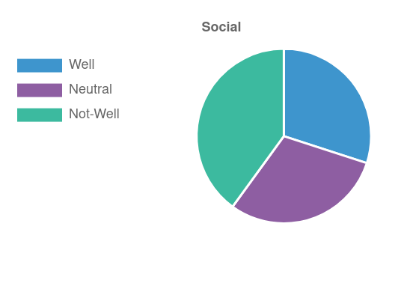

Initially, the reporting page will be blank depending on if users are already registered with the web-app. If there isn’t any data, then a graph will not be present. A blank report page will look like the below image.

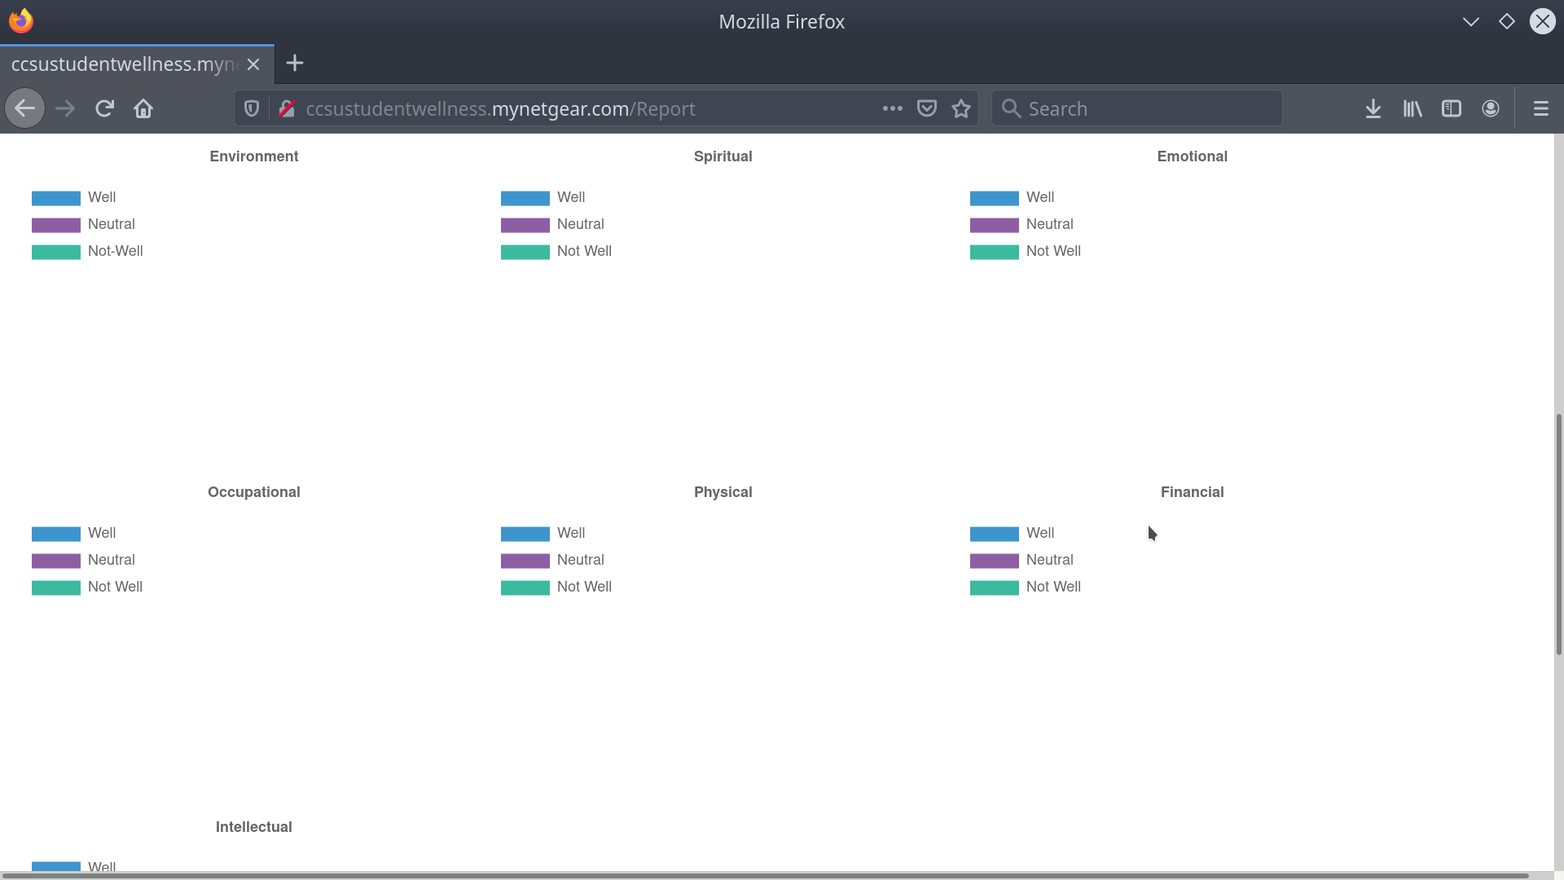

A populated report page will look like this.

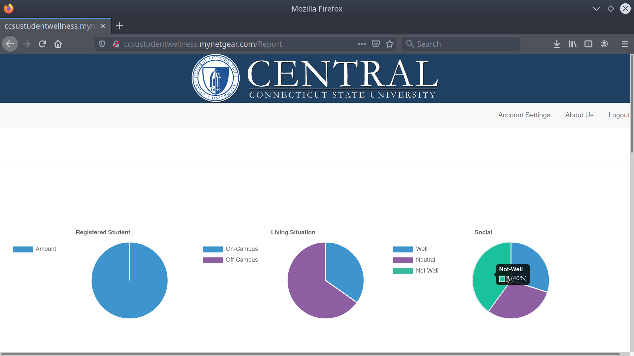

Data Perspective:

There are three main perspectives of the wellness session data:

Aggregate: The graphs will show the aggregate data for the wellness session (on and off-campus)

On-Campus: The graphs will only show the data pertaining to on-campus students

Off-Campus: The graphs will only show data pertaining to off-campus students

Below are the buttons on the page that are responsible for toggling each perspective

NOTE: The page shows Aggregate Data by default, toggling each perspective will alert the user with a note at the top of the page showing what perspective is currently in view



Clearing Data:

At the end of each semester or whenever the administrator feels the need to clear the data of the wellness session, this can be done with the click of a button.

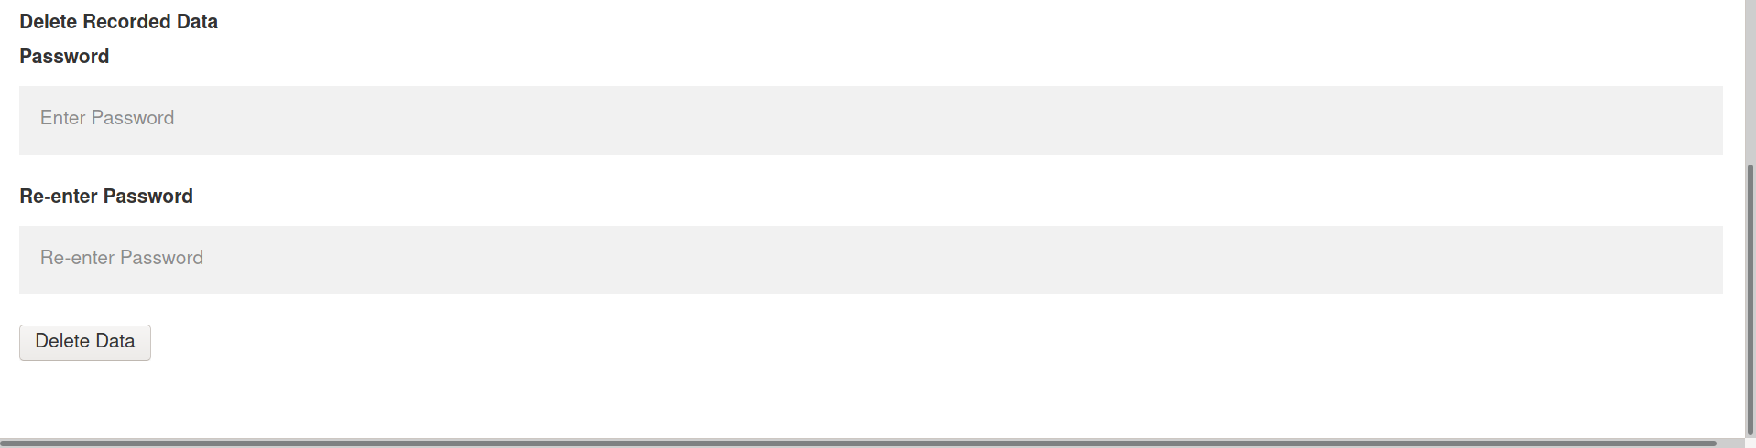

A user who is an admin will have to enter their password twice before clicking the delete data button to clear the database.

Updating Resources:

The resources displayed can be changed at any time by an administrator account by clicking the “Change Wheel Resource” button in the Account Settings page. The user will be greeted by the following page:

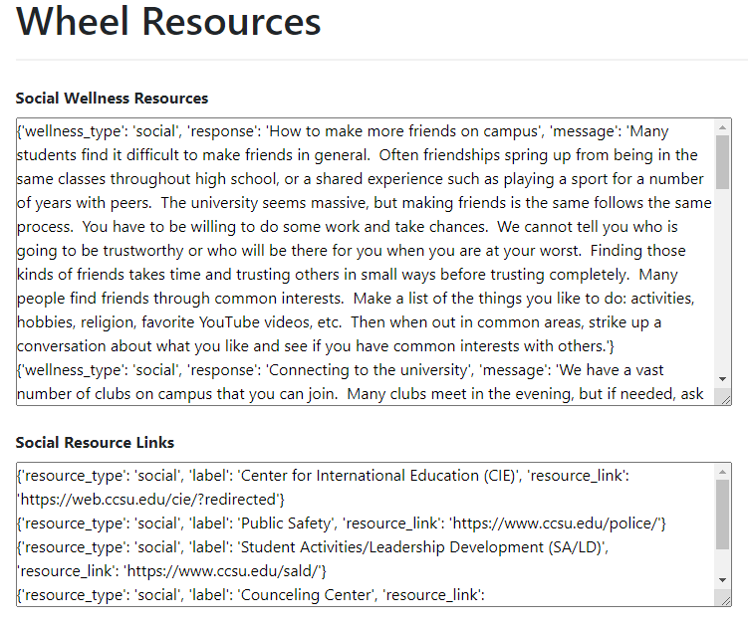

The available resources will appear followed by the links associated with that resource type. To expand the height of the textbox, the user can click and drag the square at the bottom right corner.

Resource Format:

Each resource is split into 3 parts: the wellness type, the response (or title of the resource), and the message (the actual content). An example:

{‘wellness_type’: ‘social’, ‘reponse’: ‘How to make more friends on campus’, ‘message’: ‘This is how to make friends’}

Can be changed to:

{‘wellness_type’: ‘social’, ‘reponse’: ‘How to make many friends on campus’, ‘message’: ‘This is how to make many friends around campus!’}

The resource links can be changed by following the same formatting.

Certain characters cannot be contained within the text fields above. These include:

* ‘ - apostrophe
* “ - double quote
* Tab
* \ - backslash
* % - percent
* _ - underscore

Including any of these characters will not cause any errors, however that particular resource/link will be excluded.